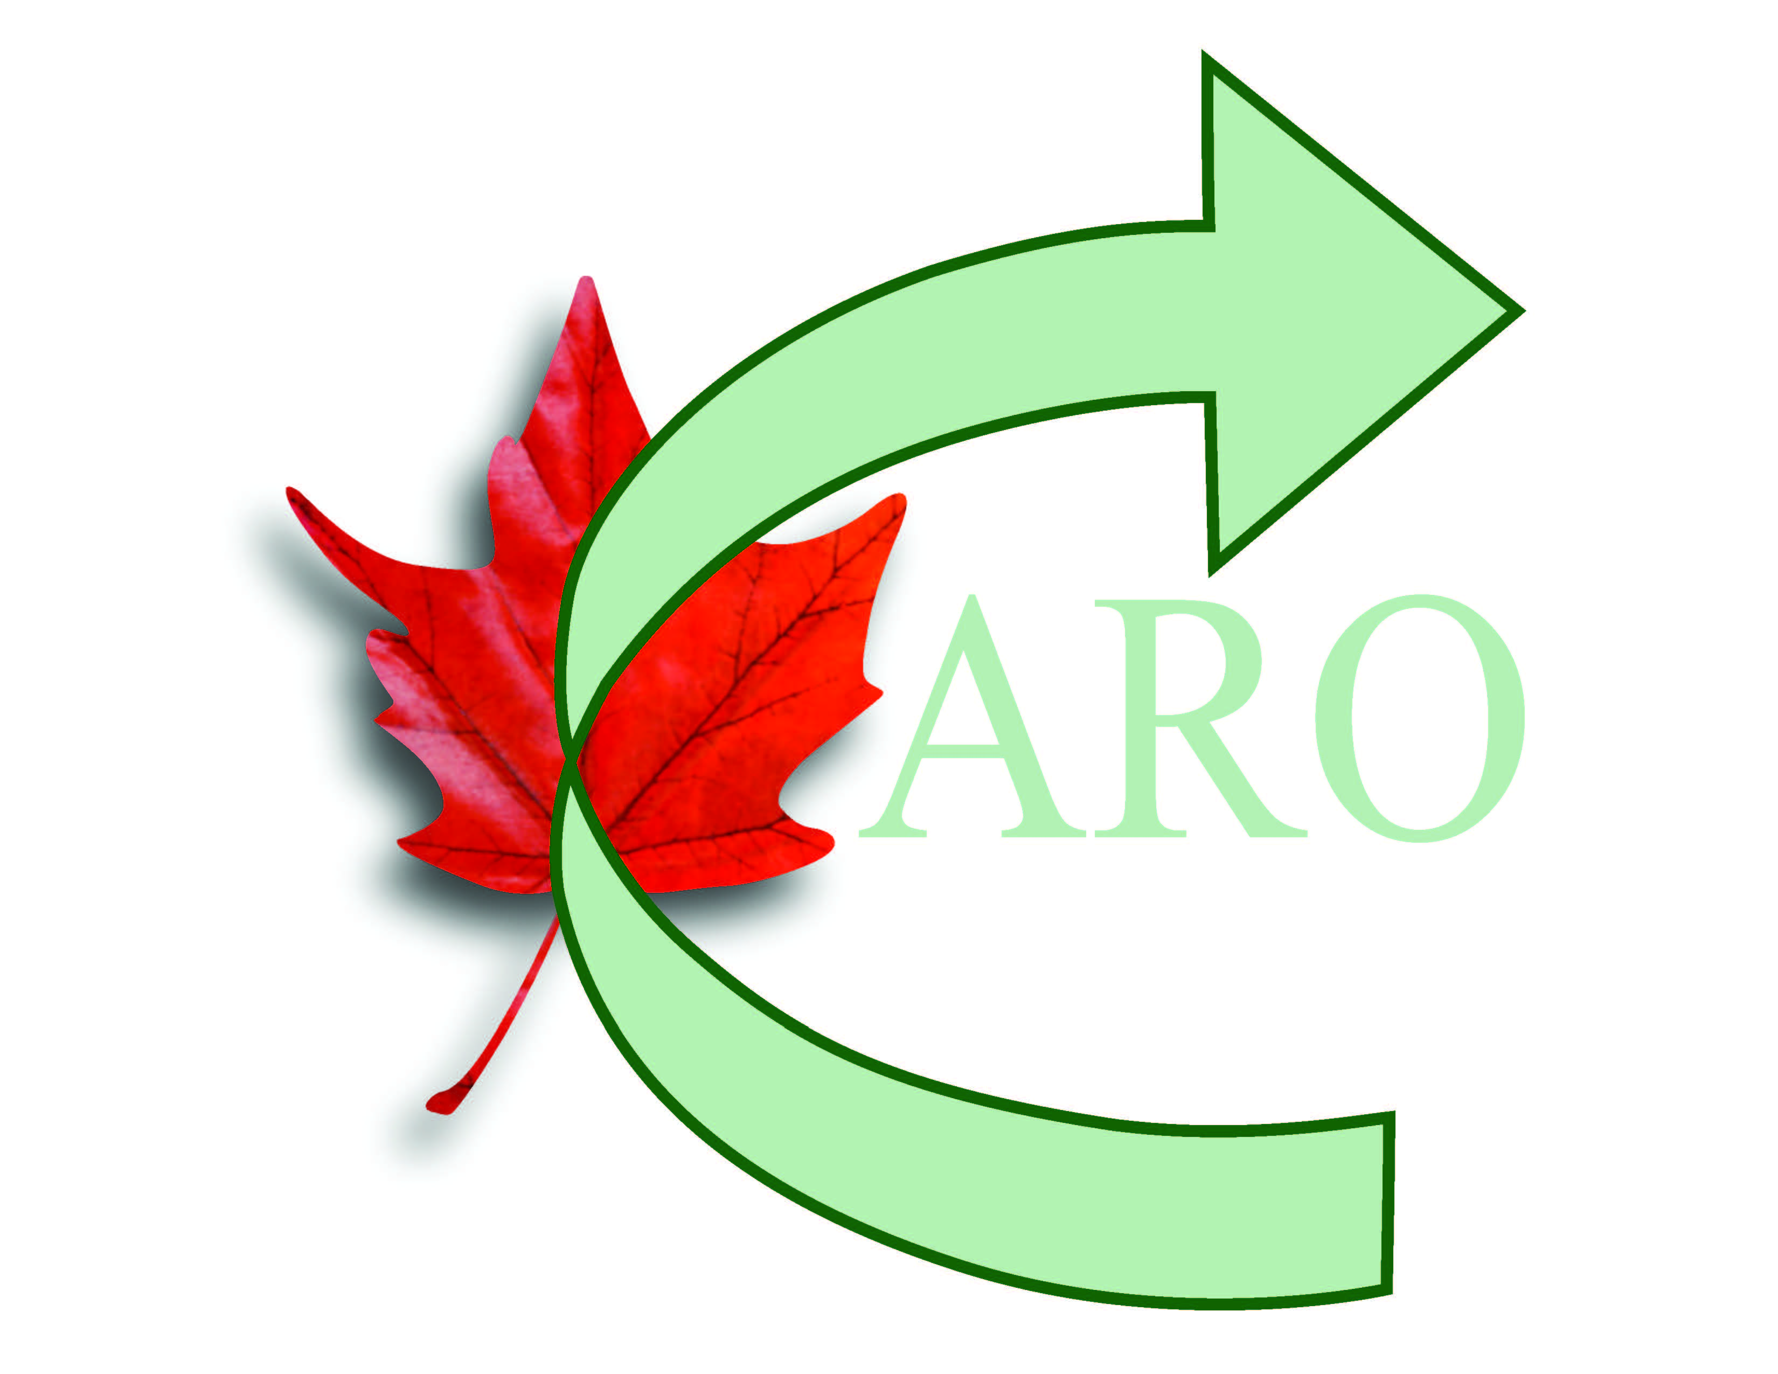
Canadian Association of Rally Obedience

Event Date: |  |  |  |  | Dog Information | Dog # 1 |  |  |  | Dog # 2
Event Location:  Round #: |  |  |  |  | CARO Dog ID #:
 |  |  |  |  | Name:
Trial #: |  |  |  |  | Breed:
 |  |  |  |  | Entry #:
   | A | B | C | Team | Brace
  Novice
  Advanced
  Excellent
  Versatility
  Versatility Exc
 |  |  |  |  | Veteran Dog: | YES ◻ |  | NO ◻ |  | YES ◻ | NO ◻
 |  |  |  |  |  | Accommodation Requested
 |  |  |  |  | Dog: | YES ◻ |  |  | NO ◻ | YES ◻ | NO ◻
 |  |  |  |  | Handler: | YES ◻ |  |  | NO ◻ | YES ◻ | NO ◻
Shoulder Height (inches) | Jump Height (inches) |  | Broad Jump  (inches) | Select One  ✓ | INITIAL POINTS: |  | 200
Under 12 | 4 |  | 8 |  | DEDUCTIONS:
12 up to 16 | 8 |  | 16 |  | FINAL SCORE:
16 up to 20 | 12 |  | 24
20 and over | 14 |  | 28 |  | TIME:
SCORING DETAILS

1 | 2 | 3 | 4 | 5
6 | 7 | 8 | 9 | 10
11 | 12 | 13 | 14 | 15
16 | 17 | 18 | 19 | 20

NQ | NQ-ET | exceeded time | NQ-LR | dog left the ring
NQ | NQ-DU | dog unmanageable | NQ-OC | off course
NQ | NQ-FL | food lure | NQ-OP | substantially out of position
NQ | NQ-IP | incomplete performance | NQ-TL | consistently tight leash
NQ | NQ-P/VC | physical or harsh verbal correction(s) | NQ-FB | knocking over food bowls, biting at bowls
Notes

Judge’s Name (please print): ______________________________

